|  |  |  |
| --- | --- | --- |
| |  |  | | --- | --- | | |  | | --- | | *Human Perspectives ATAR Units 3 & 4* | | |

Answers: Chapter 1 Investigating Biology

Questions 1.1

RECALL KNOWLEDGE

**1** List the methods of investigation used in science.

*Answer:* Observations, Controlled experiments, Surveys, Trial and error, Case studies, Longitudinal studies.

**2** Describe how observation led to our current understanding of stomach and duodenal ulcer in humans.

*Answer:* Dr Robin Warren observed the presence of bacteria in samples of stomach tissue he was examining. Continued observations over the next few years showed that bacteria were often present in the stomachs of people suffering from stomach inflammation. In collaboration with Dr Barry Marshall, it was shown that a particular species of bacterium was present in the majority of cases of stomach and duodenal ulcers, they also determined it was rare to have an ulcer without the bacterium present.

**3** Classify each of the following as either a controlled experiment, survey, case study or longitudinal study.

**a** A scientist analysed information about the diets and health conditions of 500 people in Western Australia.

*Answer:* Survey

**b** The ability to concentrate in school was investigated in 30 students. Fifteen students drank only water at breakfast, while the other 15 students drank coffee with the same breakfast.

*Answer:* Controlled experiment

**c** Casey suffers from epilepsy. Her doctors have been keeping records of the frequency, length and triggers for her seizures for the last 30 years.

*Answer:* Longitudinal study

APPLY KNOWLEDGE

**4** Discuss the implications for an investigation if more than one variable is changed.

*Answer:* If more than one variable is changed the differences in the results cannot be attributed to any one factor. You would not be able to determine which factor was impacting on the results.

**5** Explain why trial and error is often a long investigation process.

*Answer:* Trial and error is one attempt to solve a problem, followed by another. Each trial is recorded, and the results allow the investigator to home in on the solution. It is a prolonged process and may be seen as tedious, however it can result in a very successful solution.

**6** State how case studies and longitudinal studies are:

**a** similar

*Answer:* Case studies and longitudinal studies are both in-depth investigations of a particular person or situations.

**b** different.

*Answer:* They are different in that longitudinal studies are conducted over a long period of time, and may even be done retrospectively.

Questions 1.2

RECALL KNOWLEDGE

**1** Arrange the steps of the scientific method in the correct order.

*Answer:*

• Recognise a problem and define a question.

• Collect as much information as possible relating to the problem.

• Propose a hypothesis – a possible explanation for the problem.

• Test the hypothesis using an experiment.

• Analyse and interpret the data collected from the experiment.

• Draw conclusions about whether the hypothesis was supported or disproved.

• Report on the investigation.

**2** List four procedures or devices that increase safety during an investigation. For each one, describe a risk that it would be used for.

*Answer:*

Safety glasses: Worn to reduce the risk of a chemical splashing into eyes of the experimenter.

Protective clothing including gloves: To protect the investigator and to limit cross-contamination

Fire equipment including fire extinguishers, fire blankets: In the event that a chemical catches fire, to protect the individual and the laboratory

Emergency evacuation procedures: To allow for safe emptying of the building in the event of a fire or a contamination.

Students answers may vary; however they must include a reasonable risk.

**3** Define ‘ethics’.

*Answer:* A set of moral principles or values that are standards, observed by most people in our society.

**4** Describe the principle of informed consent with regards to investigations involving humans.

*Answer:* The subjects should be fully informed about the objectives of the research, the procedures to be followed, any possible risks and the potential benefits of the research. Consent should only be sought after all information has been given.

**5** Match the description with the relevant term.

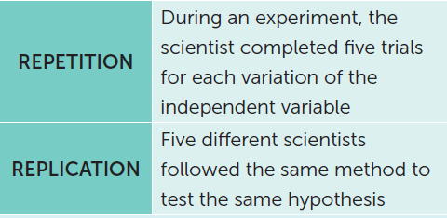

*Answer:* Terms are matched correctly.

APPLY KNOWLEDGE

**6** Explain why an investigation may disprove a hypothesis but not prove it.

*Answer:* An investigation, conducted correctly, may provide results that disprove the hypothesis. Results that are expected, will only support the hypothesis. It is generally impossible to test all possible cases for exceptions that would disprove a hypothesis.

**7** Literature review is an important component of a scientific investigation, as it allows scientists to assess methods used by others. Explain why this improves an investigation.

*Answer:* Literature reviews help define the problem, they help find out what is already known about the problem to reduce duplication of effort and allows the researcher to build on what is already known. Literature reviews are used to assess research methods or to allow for adaptation to the researcher’s own investigation, and to allow researchers to relate their findings to what is already known.

**8** A group of students was testing the following hypothesis: ‘Drinking caffeine increases focus while studying.’ The students tested 20 Year 12 students, with five girls and five boys drinking a can of cola prior to studying and five girls and five boys drinking the same volume of water prior to studying. The time each student remained focused during their study was recorded.

**a** State the independent variable for the investigation.

*Answer:* Caffeine

**b** State the dependent variable for the investigation.

*Answer:* The time each student was focused during study.

**c** Describe the control group.

*Answer:* The five boys and girls drinking the same volume of water.

**d** Rewrite the hypothesis to better reflect what was tested.

*Answer:* Drinking caffeine will increase the length of time students in Year 12 can focus during study.

If caffeine is drunk, then the length of time a student can focus for will be longer.

Other responses may be acceptable, the hypothesis must include both variables and show a relationship.

**e** Was the investigation valid? Justify your answer.

*Answer:* No, this experiment is not valid. There are other factors that have not been controlled including the time of day the experiment was conducted, the diet of the students, if other distractions (for example music) were removed from the studying, the time of the day the studying was carried out in.

**9** During an investigation about the effect of different types of exercise, the following pulse rates, in beats per minute, were recorded prior to exercise.

54 65 62 58 60 66 84 57 61 65 59 63

**a** Calculate the mean for the data.

*Answer:* 60.91 beats per minute (excluding the outlier of 84).

62.83 beats per minute (including the outlier of 84)

**b** Identify any outliers in the data.

*Answer:* 84 beats per minute

**c** State the median pulse rate.

*Answer:* The median is 61, if you exclude the outlier of 84. Including the outlier, the median is 61.5.

**d** State the range for the data.

*Answer:* 54 – 84 beats per minute.

**e** During exercise, the mean pulse rate was 96 beats per minute. Calculate the percentage increase in pulse rate due to exercise.

*Answer:* 57.6% increase.

**10** The average heights of males of different ages are shown in the table. Construct an appropriate graph to represent the data.

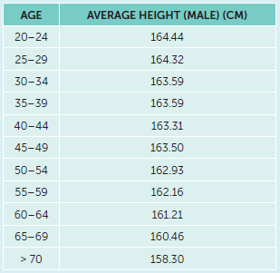

*Answer:*

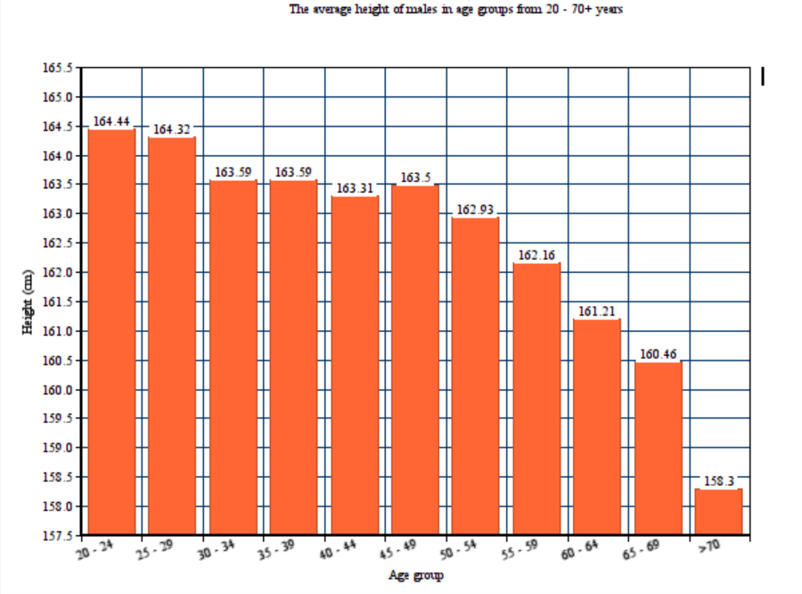

Graph must be a column graph, columns not touching, title including two variables, even intervals on the scales, scale break may be accepted.

Questions 1.3

RECALL KNOWLEDGE

**1** State the reasons that peer reviews are an important part of scientific investigations.

*Answer:* A peer review is undertaken to make sure the report is worthy of publication. The process keeps scientific literature free of incorrect, bogus or misleading information.

**2** Describe what you should include in each of the following sections of a scientific report:

**a** introduction

*Answer:* State the nature of the problem investigated and the hypothesis tested.

**b** method

*Answer:* Describe the exact method used to carry out the investigation.

**c** results

*Answer:* The data collected from the investigation, presented as tables, graphs, diagrams or photographs.

**d** conclusion

*Answer:* Summarises the most important parts of the discussion and states whether the hypothesis was supported.

**e** acknowledgements.

*Answer:* The people who helped with the investigation or of organisations that provided funds for the research.

**3** Where did people believe micro-organisms came from prior to Pasteur’s investigations?

*Answer:* Spontaneous generation: the living organisms develop spontaneously from non-living matter.

APPLY KNOWLEDGE

**4** The largest part of a scientific report is the discussion. The information presented in the discussion can be classified as:

• discussing the results and their implications

• evaluating the results

• evaluating the method.

Classify each of the following according to these options.

**a** Were there any defects in the design of the investigation or in the procedure?

*Answer:* evaluating the method.

**b** Were any results different from those expected?

*Answer:* evaluating the results

**c** How do the results fit into the broader context of what is already known about the topic?

*Answer:* discussing the results and their implications

**d** Did the results support the hypothesis, or did they indicate that the hypothesis was incorrect?

*Answer:* evaluating the results

**e** Could the investigation have been improved in any way?

*Answer:* evaluating the method.

**f** Were there any variables that could not be controlled?

*Answer:* evaluating the method.

**g** Was there any bias in the results?

*Answer:* evaluating the results

**5** Explain how Pasteur’s investigation using broth in flasks with different necks was able to support the hypothesis ‘that microorganisms occur in sterile culture medium only when exposed to contaminated air from the outside’.

*Answer:* Pasteur used two different necks in his experiment, the straight neck resulted in cloudy broth, due to the activity of microorganisms, and the S-shaped curve neck remained clear as the air with the microorganisms was not able to reach the broth. Only one factor was changed (the neck shape) and the results clearly indicated that the straight neck would allow microorganisms to contaminate the sterile culture medium. As there was only one factor changed and a clear result provided, the investigation supports the hypothesis.

**6** Discuss the importance of Tyndall and Chamberland’s work supporting Pasteur’s in disproving the idea of spontaneous generation.

*Answer:* Tyndall’s work showed that a sterile broth exposed to air, but no dust would remain sterile indefinitely and Chamberland, working as Pasteur’s assistant, discovered some bacteria produce spores that can withstand high temperatures. Both scientists contributed to the one idea and provide supporting evidence to refute the idea of spontaneous generation.

CHAPTER 1 ACTIVITIES

Activity 1.1 Researching for Mightypharm

**Stage 1**

*Answer:*

• Hypothesis: Compound A from the Brazilian toadstool will inhibit bacterial growth.

• Method: This could be tested using agar plates inoculated with various bacteria. A disc containing

Compound A could then be placed in the centre of each plate.

• Results: If Compound A inhibits bacterial growth, there will be a ring of clear agar (no bacterial growth) around the disc. The wider the clear area, the greater the effect of the compound.

• Students may suggest a range of other methods, such as adding liquid containing Compound A to agar plates with bacterial species, or adding the liquid to bacterial cultures in test tubes.

**Stage 2**

*Answer:*

• Inject rats, mice or other test animals with bacteria. Wait for symptoms of disease to develop. Inject Compound A in varying doses into some test animals; other test animals to be kept as controls.

• Compare the test animals with the controls to determine whether there are any side effects associated with use of Compound A.

Ethical considerations:

• Minimise any harm and suffering to the test animals.

• Decide whether Compound A shows sufficient promise as an antibiotic to justify experimenting with it on test animals.

• Decide whether, despite any adverse effects on the test animals, the outcome will be for the greater good.

**Stage 3**

*Answer:*

Repeat stage 2, but using human subjects. Perform a double-blind experiment. All subjects to have bacterial infections to be as similar as possible in age, fitness and so on. To half the subjects, give antibiotic doses that were optimal on test animals, but take into account human body mass. To the other half of the subjects, give a placebo that looks identical to the antibiotic. Neither the experimenters nor the subjects are to know who is getting the antibiotic and who is getting the placebo.

Ethical considerations:

• Make subjects aware of the procedure and the possible risks; gain informed consent.

• Subjects must be of an appropriate age to give consent to participate.

Activity 1.2 Validating Pasteur’s experiment

**Studying your results**

**1** Describe your results, giving a description of the broth in each flask.

*Answer:* Responses will vary. However, it is expected that the broth in the flask with the S-shaped tubing will remain clear, while that in the flask with straight tubing will become cloudy.

**2** Combine your results with those of other groups in the class. Explain the advantage of combining results.

*Answer:* More results increase the reliability of the overall experiment. The more repetitions of the

experiment the lower the risk of uncontrolled variables making an impact on the data/observations.

**3** Were your results similar to Pasteur’s? Were the class results similar to Pasteur’s?

*Answer:* Responses will depend on the actual results; however, if done carefully, the experiment should yield results similar to Pasteur’s.

**4** If your results were not similar to Pasteur’s, can you suggest any explanation?

*Answer:* Explanations could include the following:

• Different location compared with Pasteur’s original experiment

• Broth is different from that used by Pasteur

• Temperature of broth may have been different

• Boiling the flasks may not have destroyed all micro-organisms

• Bacterial and fungal spores in the air different from those that Pasteur encountered.

**5** If you were to repeat the experiment, how could you improve it?

*Answer:* Improvements could be:

• making sure that all measurements are accurate and precise

• leaving the flasks at a predetermined temperature that is controlled throughout the experiment

• controlling the environment; for example, making sure there is no animal or human contact

• sterilising the flasks in a pressure cooker/autoclave to make sure all spores are killed.

CHAPTER 1 REVIEW QUESTIONS

Recall

**1** What is a controlled experiment?

*Answer:* In a controlled experiment, one variable is deliberately changed, while all the other variables are kept the same. Any differences between the results for the group in which the variable was changed and the group in which it was unchanged must be due to the changed variable.

**2** List four principles that must be satisfied if an investigation is to be ethical.

*Answer:* Some of the principles that an investigation involving humans must satisfy if it is to be ethically sound are:

• Any involvement in the investigation must be voluntary. There should be no coercion of subjects to

take part.

• Potential subjects must be given all necessary information about the investigation, particularly any

risks involved.

• There should be no risk of any physical or psychological harm to any of the subjects.

• The identities of participants and their particular results should not be revealed except to people

directly involved in the study.

**3** What is a literature review and what are some of the reasons for carrying out such a review?

*Answer:* A literature review is a survey of the material that has been written about a subject under

consideration. It is a way of finding out what is already known about a subject.

The purpose of a literature review is to:

• define the problem so that a suitable hypothesis can be proposed

• prevent duplication of effort by finding out what is already known about a problem

• allow the researcher to build on knowledge that is already available

• review research methods so that those used by other investigators may be used or adapted for the

researcher’s own investigation

• allow any findings from an investigation to be related to what is already known.

**4** Describe how you would calculate the mean of a set of measurements.

*Answer:* You would consider the data set, remove any outliers first. Then add up all the measurements and divide that total by the total number of measurements.

**5** What are outliers? Should outliers be excluded when drawing conclusions from a set of data?

*Answer:* A set of measurements may contain values that are well beyond the range of the rest of the

measurements. These are called outliers. If outliers were included in the calculation of the mean it would make the mean higher or lower than it would have been without the outlier included. If the outliers are clearly the result of an error, then researchers would be justified in excluding them when the mean is calculated.

**6** Describe what a peer review is and why they are used.

*Answer:* Before a scientific report is published it is usually subject to a peer review. It is sent to one or more experts in the field to check for errors, ambiguities or misleading information. The review will then recommend whether the report be published or not. Such reviews are used to try to make sure that scientific reports are worthy of publication.

**7** Describe some of the points that should be included in the discussion section of a scientific report.

*Answer:* The discussion section of a report should address all aspects of the research including the

methodology and the results.

Points that should be addressed in the discussion include:

• description of any defects in the design of the investigation or in the procedure

• results that differ from those expected

• analysis of how the results fit into the context of what is already known about the topic

• practical applications for the results

• relationship of the findings to earlier work in the same area

• whether the results support the hypothesis, or demonstrate that the hypothesis is incorrect

• description of any limitations in the research

• suggestions for improving the investigation

• description of any variables that could not be controlled

• an account of any bias in the results

• any information from other reliable sources that supports the results

• description of any further research needed to clarify the results.

**8** What is an ‘error’ when discussing a scientific investigation?

*Answer:* In an investigation an error is any deviation from the result that should have been obtained.

Explain

**9** Explain the difference between:

**a** observations and surveys

*Answer:* Observations are generally much broader than surveys. For example, a person may observe something and then propose a hypothesis to account for the situation observed. Observations may be more systematic such as when observing animal behaviour.

Surveys are directed towards collecting information about a specific subject. Large amounts of data can be collected, analysed and any patterns recognised.

**b** longitudinal studies and case studies.

*Answer:* A case study looks at one particular ‘case’ – a particular situation or person. Changes in the situation or person are documented.

A longitudinal study looks at a situation over a prolonged period of time – possibly many years. Patterns of change can then be recognised.

**10 a** What is a hypothesis?

*Answer:* A hypothesis is a possible explanation for observations, or a possible solution to a problem. A hypothesis should be stated in such a way that it is capable of being tested.

**b** Can a hypothesis be proved? Explain.

*Answer:* A hypothesis cannot be proven although it may be disproved. The results of a correctly designed experiment will either support the hypothesis or will disprove the hypothesis.

**11 a** Explain the difference between the dependent and the independent variable in an experiment.

*Answer:* A variable is any factor that may change during an experiment. The independent variable is the factor that is being investigated. It is deliberately changed to determine its effect. The dependent variable is the factor that changes in response to any changes made to the independent variable.

**b** Explain the difference between controlled and uncontrolled variables.

*Answer:* Controlled variables are the factors that are kept the same for both the control and experimental groups in an experiment. Uncontrolled variables are variables that are not kept the same for the control and experimental groups in an experiment. They may have been overlooked by the experimenter or may have been impossible to control.

**12** Use an example to explain the difference between the validity and the reliability of an investigation.

*Answer:* Validity refers to testing only what you set out to test, and reliability will result in the same results each time the test is undertaken. Example: If students participate in five minutes of HIIT exercise, then their heartrate will increase. This experiment will be valid provided the students are of a similar age, gender, physical fitness and consume the same diet, exercise at the same time of day and use digital equipment to measure the heartrate prior and post the HIIT exercise. The experiment will be seen to be reliable when after multiple trials the heartrates consistently rise after each exercise time.

**13** Explain the difference between qualitative and quantitative data.

*Answer:* Data from an investigation can be either of the following:

• Quantitative data. This is expressed in numbers and usually involves measurement.

• Qualitative data. These are observations that do not involve numbers or measurement.

Apply

**14** Re-read the account of Florey’s experiment in which he injected mice with penicillin (page 4). List the variables that Florey controlled in his experiment.

*Answer:* Florey’s controlled variables included the following:

• All animals tested were mice.

• The mice were all the same weight.

• All mice were the same age.

• Each was injected with the same species of bacterium (*streptococci*).

• Each was injected with 100 million of the *streptococci*.

• Each was injected at the same time.

**15** What did Albert Einstein mean when he said: ‘No amount of experimentation can ever prove me right; a single experiment can prove me wrong’?

*Answer:* A hypothesis may be disproved, but it cannot be proved. The results of an experiment can only provide support for the hypothesis. No amount of experimentation could prove a hypothesis to be correct, but one experiment could prove the hypothesis to be wrong.

**16** Identify the type of investigation that would be the best for finding a solution to the following problems. Explain the reasons for your choice in each case.

**a** Can people taste the difference between two different brands of milk chocolate?

*Answer:* A controlled experiment. This problem requires one variable to be changed (the brand of chocolate) while all others are kept the same.

**b** What proportion of students in your school are left-handed?

*Answer:* A survey. Students need to be questioned about their dominant hand.

**c** What is the ratio of males to females in your Human Biology class?

*Answer:* A survey. A count needs to be made of the number of males and females.

**d** How has a particular person’s growth rate changed from birth to age 15?

*Answer:* A case study or longitudinal study. It will be necessary to review the data on one individual over 15 years.

**17** In addition to physical activity that is part of their job or daily routine, many people deliberately exercise by going to a gym or by walking or jogging. Describe how you would conduct a survey to find out the average amount of time the teachers at your school spend on deliberate exercise.

*Answer:* Create a survey form (a questionnaire) for each teacher to complete. The form could include a table in which the teacher records time spent on any ‘deliberate’ exercise done during each day over a week-long period. (This could also include the type of exercise, the time they started the exercise and the time they completed it). By adding the responses from all the teachers, the average exercise time for teachers at the school could be calculated.

**18** The table below shows the systolic blood pressure of students in a Year 12 Human Biology class.

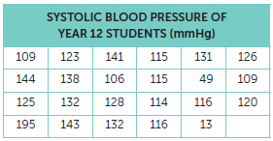

**a** Are there any obvious outliers in the data in the table? If so, which are the outliers and why should they be regarded as outliers?

*Answer:* Readings 49 and 195 are obviously outliers, because they are considerably lower and higher than most students’ blood pressures.

**b** Calculate the mean systolic blood pressure for the class, excluding any outliers.

*Answer:* The mean systolic blood pressure for the class is 123.6 mmHg.

**c** What is the range of blood pressures in the class?

*Answer:* The range of blood pressures is from 49 to 195 mmHg or, if outliers are excluded, from 106 to 144 mmHg.

**d** What percentage of students had a blood pressure of 130 mmHg or higher?

*Answer:* If the outlier is excluded, 30.4%; if included, 34.7%.

**e** The average systolic blood pressure for adults is 120 mmHg. What proportion of students have blood pressures above this average?

*Answer:* The proportion is 12:11, or 11:11 if the outlier is excluded. Students may legitimately say half or 50%.

**19** Researchers investigating the benefits of exercise in preventing heart disease studied the health outcomes for women after participating in an exercise program. They calculated the risk of heart disease at 0.18 with a confidence interval of 0.04 to 0.80 at the 95% confidence level. Explain what the data means.

*Answer:* The data mean that for 95% of the participating women the risk of heart disease will be between 0.04 and 0.80.

Extend

**20** In 2003, a team of Australian anthropologists discovered skeletal remains on the Indonesian island of Flores. One skeleton was of a small human with a small brain, and dating showed it to be 18 000 years old. The team claimed it was a new species of human and named it *Homo floresiensis*. Experts are divided on whether the discovery is a new type of human or whether there is some other explanation for the small stature and small brain. This is a good example of scientific debate about the meaning of data. Use the Internet to find out some of the hypotheses put forward to explain why the skeleton is really our own species, *Homo sapiens*.

*Answer:* Three possible sites that students may find include the following.

• [www.crystalinks.com/hobbit.html](http://www.crystalinks.com/hobbit.html)

• <http://humanorigins.si.edu/evidence/human-fossils/species/homo-floresiensis>

• <http://australianmuseum.net.au/homo-floresiensis>

There are a few popular evolutionary hypotheses around *Homo floresiensis*.

One: *Homo floresiensis*is the dwarfed descendantof *Homo erectus*.

Two: *Homo floresiensis*is the descendant of an even more primitive species.

Three: *Homo floresiensis*represents an unknown and very early migration out of Africa.

**21** A research method sometimes used by scientists is meta-analysis. Find out what is meant by ‘meta-analysis’ and give an example of an investigation that used this method of research.

*Answer:* Meta-analysis is a quantitative, formal, epidemiological study design used to systematically assess the results of previous research to derive conclusions about that body of research. It is used to combine data from multiple studies to determine a common effect or to provide reason for variation. A real-life example includes the meta-analysis on whether physical activity during pregnancy prevents postpartum depression.

**22** Some controlled experiments are said to be ‘double-blind’ experiments. Find out what is meant by the term ‘double-blind experiment’ and give examples of how such experiments might be used.

*Answer:* A double-blind experiment is one where neither the participants nor the experimenters know who is receiving a particular treatment. The procedure is utilised to prevent bias in research results. They are particularly useful for preventing bias due to the placebo effect. Blinding has high efficacy in pharmacological trials provided that good clinical protocol is followed.